**Industrial Internship Report on**

“Forecasting of Smart city traffic patterns”

**Prepared by: Pragati Kedia**

|  |
| --- |
| *Executive Summary* |
| This report provides details of the Industrial Internship provided by upskill Campus and The IoT Academy in collaboration with Industrial Partner UniConverge Technologies Pvt Ltd (UCT).  This internship was focused on a project/problem statement provided by UCT. We had to finish the project including the report in 6 weeks’ time.  My project was Forecasting of Smart city traffic patterns  This internship gave me a very good opportunity to get exposure to Industrial problems and design/implement solution for that. It was an overall great experience to have this internship. |

**TABLE OF CONTENTS**

1 Preface 3

2 Introduction 4

2.1 About UniConverge Technologies Pvt Ltd 4

2.2 About upskill Campus 8

2.3 Objective 9

3 Problem Statement 11

4 Existing and Proposed solution 12

5 Proposed Design/ Model 13

6 Performance Test 14

6.1 Performance Outcome 14

7 My learnings 15

8 Future work scope 16

# Preface

During these weeks preprocessing of the dataset, the model implementation, graph plotting everything is done.

The progress is shown below:

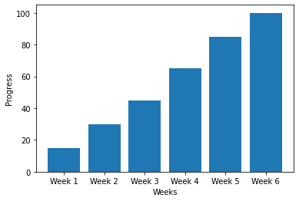

Internship helps in giving industrial experience as well as enhances the skills which helps in future as well.

This report is about a data analytics project and the name is **“Forecasting of Smart city traffic patterns”**. The main objective is to predict the traffic patterns on different junctions using machine learning algorithms and give some insights.

How Program was planned

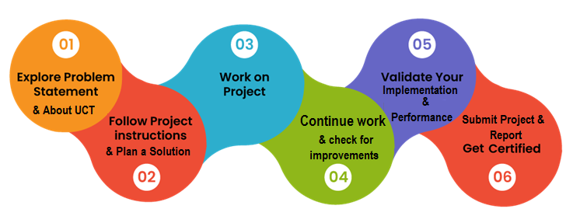

It was a nice experience for me while doing this project and it also helps me to improve my skills. I learnt a lot from this internship.

Thanks to full UCT team for giving me this wonderful opportunity .

# Introduction

## About UniConverge Technologies Pvt Ltd

A company established in 2013 and working in Digital Transformation domain and providing Industrial solutions with prime focus on sustainability and RoI.

For developing its products and solutions it is leveraging various**Cutting Edge Technologies e.g. Internet of Things (IoT), Cyber Security, Cloud computing (AWS, Azure), Machine Learning, Communication Technologies (4G/5G/LoRaWAN), Java Full Stack, Python, Front end**etc.

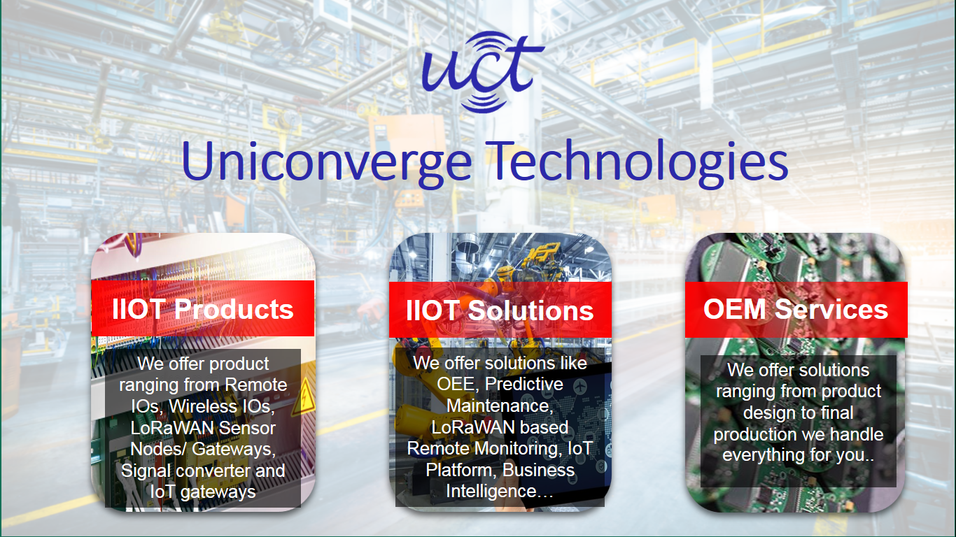

1. UCT IoT Platform**(****)**

**UCT Insight** is an IOT platform designed for quick deployment of IOT applications on the same time providing valuable “insight” for your process/business. It has been built in Java for backend and ReactJS for Front end. It has support for MySQL and various NoSql Databases.

* It enables device connectivity via industry standard IoT protocols - MQTT, CoAP, HTTP, Modbus TCP, OPC UA
* It supports both cloud and on-premises deployments.

It has features to  
• Build Your own dashboard  
• Analytics and Reporting  
• Alert and Notification  
• Integration with third party application(Power BI, SAP, ERP)  
• Rule Engine





1. **Smart Factory Platform ()**

Factory watch is a platform for smart factory needs.

It provides Users/ Factory

* with a scalable solution for their Production and asset monitoring
* OEE and predictive maintenance solution scaling up to digital twin for your assets.
* to unleased the true potential of the data that their machines are generating and helps to identify the KPIs and also improve them.
* A modular architecture that allows users to choose the service that they what to start and then can scale to more complex solutions as per their demands.

Its unique SaaS model helps users to save time, cost and money.

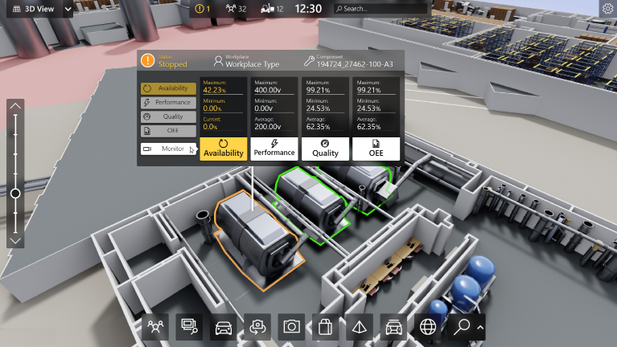

1. Based Solution

UCT is one of the early adopters of LoRAWAN teschnology and providing solution in Agritech, Smart cities, Industrial Monitoring, Smart Street Light, Smart Water/ Gas/ Electricity metering solutions etc.

1. Predictive Maintenance

UCT isproviding Industrial Machine health monitoring and Predictive maintenance solution leveraging Embedded system, Industrial IoT and Machine Learning Technologies by finding Remaining useful life time of various Machines used in production process.



## About upskill Campus (USC)

upskill Campus along with The IoT Academy and in association with Uniconverge technologies has facilitated the smooth execution of the complete internship process.

USC is a career development platform that delivers **personalized executive coaching** in a more affordable, scalable and measurable way.



Seeing need of upskilling in self paced manner along-with additional support services e.g. Internship, projects, interaction with Industry experts, Career growth Services

UpSkill Campus aiming to upskill 1 million learners in next 5 year

<https://www.upskillcampus.com/>

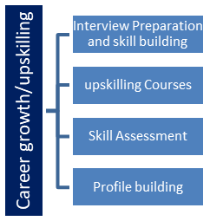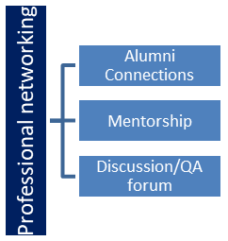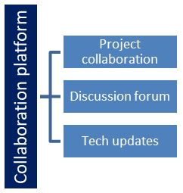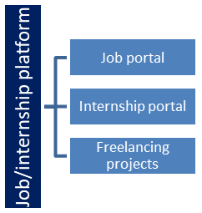

## The IoT Academy

The IoT academy is EdTech Division of UCT that is running long executive certification programs in collaboration with EICT Academy, IITK, IITR and IITG in multiple domains.

## Objectives of this Internship program

The objective for this internship program was to

 ☛ get practical experience of working in the industry.

 ☛ to solve real world problems.

 ☛ to have improved job prospects.

 ☛to have Improved understanding of our field and its applications.

 ☛to have Personal growth like better communication and problem solving.

## 

# Problem Statement:

**Forecasting of Smart city traffic patterns**

* Smart cities are rapidly emerging as the future of urban development, incorporating advanced technologies to enhance the quality of life for residents. One critical aspect of smart cities is efficient traffic management, as urban areas face increasing challenges related to congestion, pollution, and time wasted in traffic. To address these issues, accurate forecasting of smart city traffic patterns has become a crucial area of research and development.
* The forecasting of smart city traffic patterns involves predicting the flow of vehicles, identifying congestion-prone areas, and anticipating future traffic demands. By leveraging data from various sources such as sensors, GPS devices, traffic cameras, and social media platforms, cities can gain valuable insights into traffic patterns, enabling them to make informed decisions for effective traffic management and optimization.
* The importance of accurate traffic pattern forecasting cannot be overstated. It allows city authorities to proactively allocate resources, optimize traffic signal timings, implement dynamic routing strategies, and improve transportation infrastructure planning. Additionally, accurate predictions can assist commuters in making informed decisions regarding travel routes and modes of transportation, thereby reducing travel time, fuel consumption, and environmental impact.
* The objective of this project report is to explore and analyze different methods, techniques, and models for forecasting smart city traffic patterns. By investigating the existing research in this field and conducting experiments using real-world traffic data, we aim to contribute to the advancement of traffic forecasting capabilities and provide valuable insights for smart city planners, traffic engineers, and policymakers.

# Existing and Proposed solution

Algorithms like Random forest, Decision tree, SVM and XGboosting are used during model training. Predictions are giving as a graph format and approx. 95% the model is accurate. Hence it can easily identify and predicted the traffic congested area.

## Code submission (Github link)

https://github.com/pragsz/upSkill_Campus.git

## Report submission (Github link) :

https://github.com/pragsz/upSkill_Campus.git

# Proposed Design/ Model

The predicted vs actual traffics are given as follows:

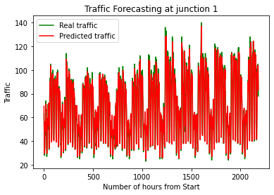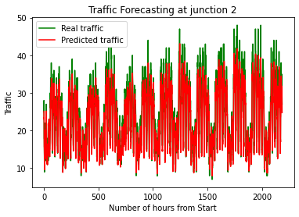

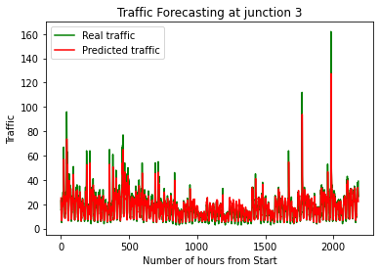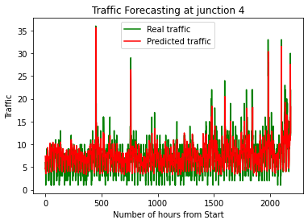

# Performance Test

## Performance Outcome:

The accuracy graphs of all the models are as follows:

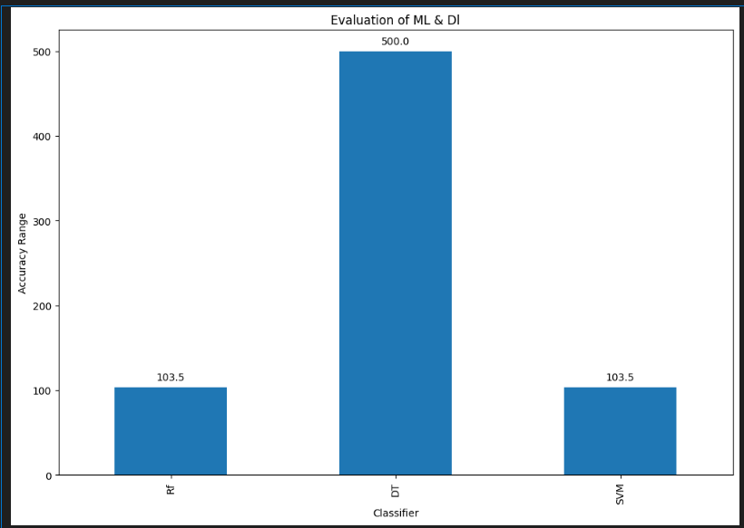

# My learnings

* Helps me to enhance my technical skills.
* During this program I learnt lot of things and gained industrial knowledge which will surely help me in future.
* I can also identify my areas of improvement and I am started working on that.

# 8 Future work scope

In future it can be used on GPS where the model will predict previously the traffic congested areas and people can easily get rid out of this. This model required more improvements